Bash Scripting Assessment

Subject – Operating system (using docker desktop) ubuntu

Submitted To :Dr.Sonia Gul

# Submitted by : Abhishek sharma

# Id : 1000117797

GITHUB :<https://github.com/abhishek-2110/abhi_bash_assignment.git>

# Step 1

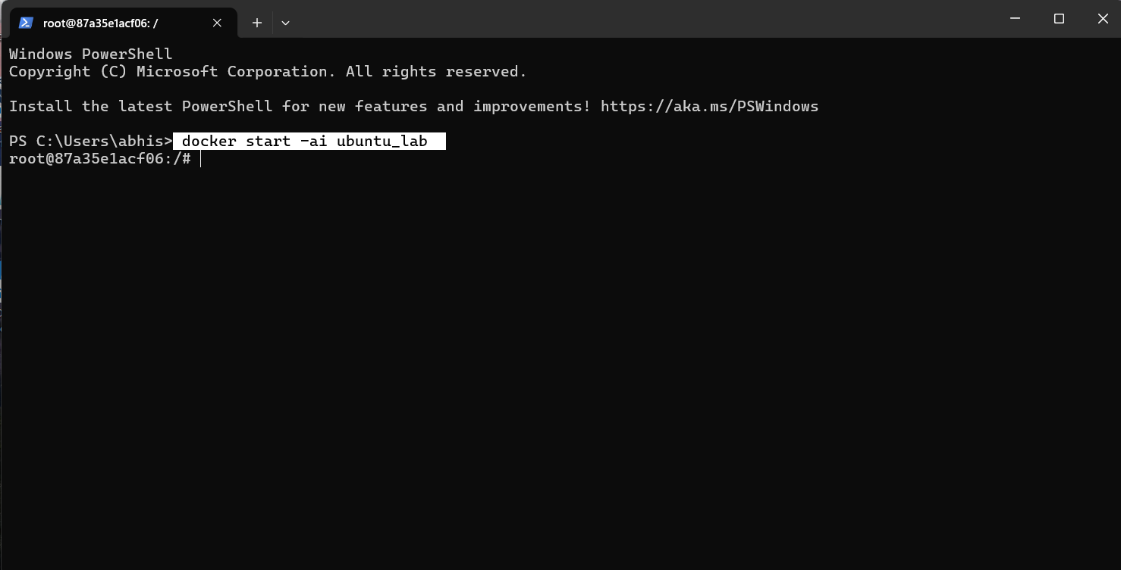

# Step 2

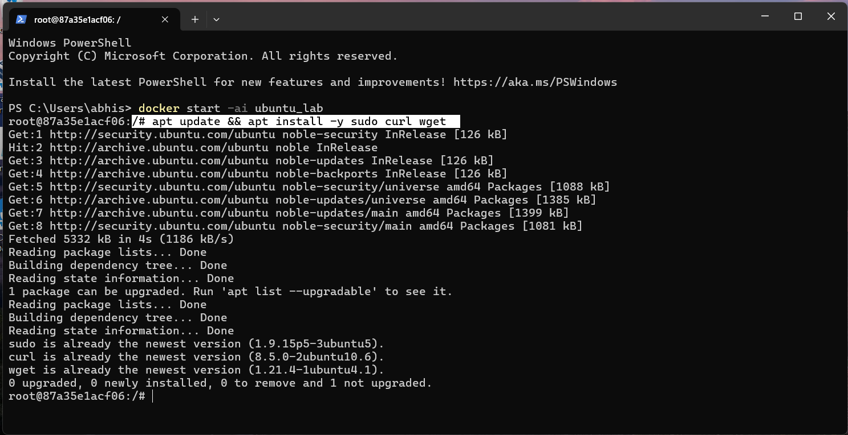

Step 3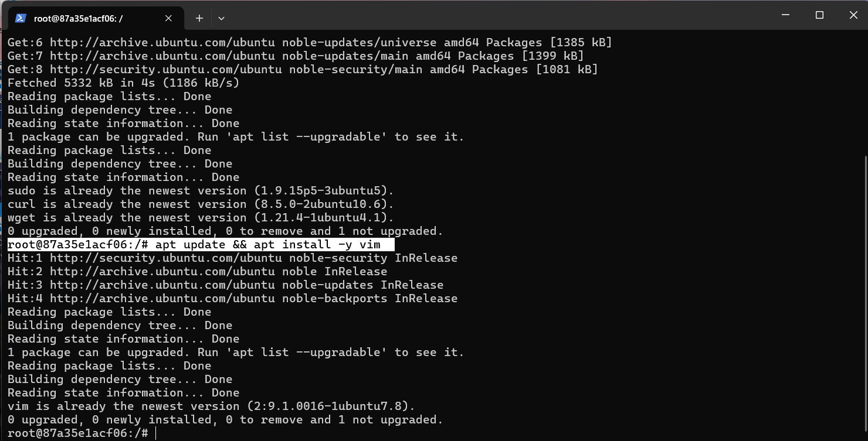

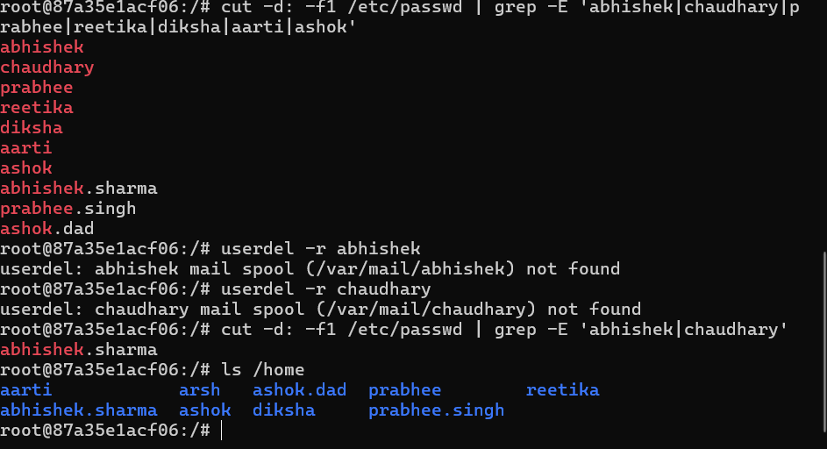

4

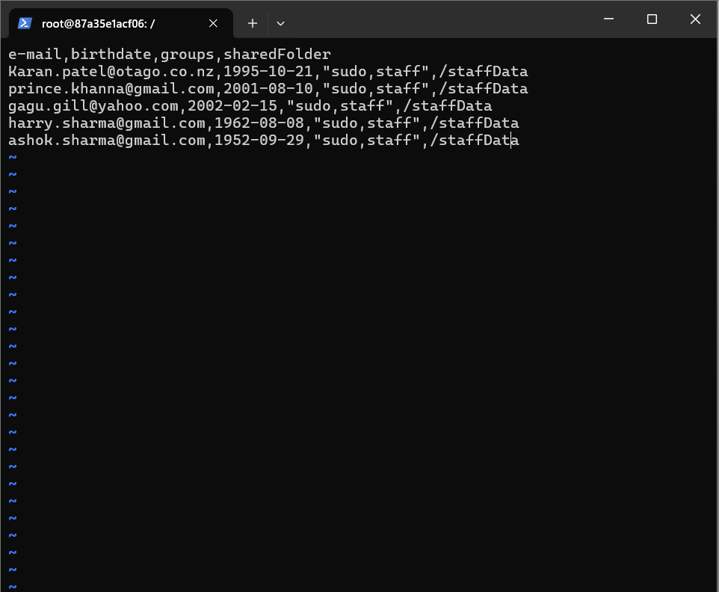

Esc

:wq



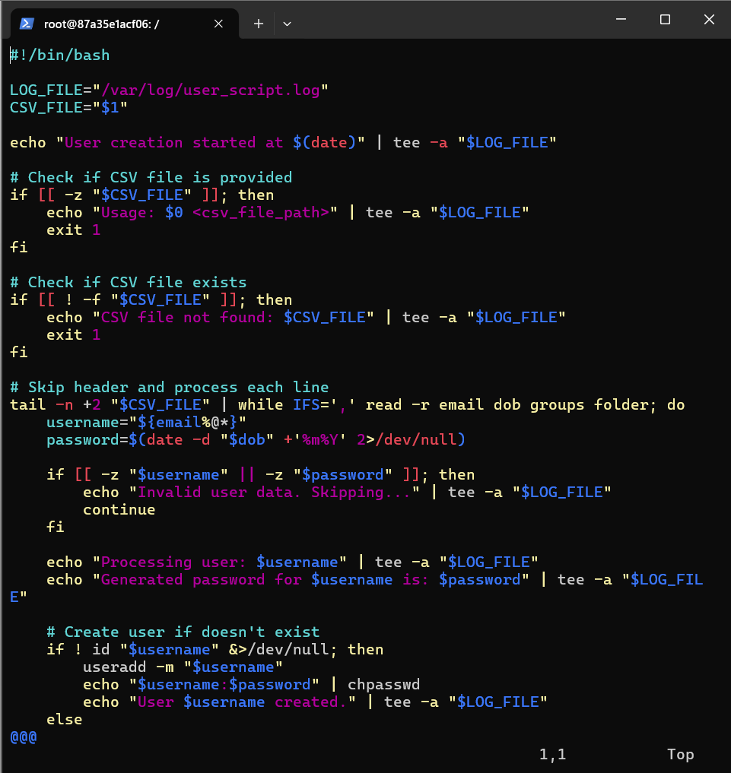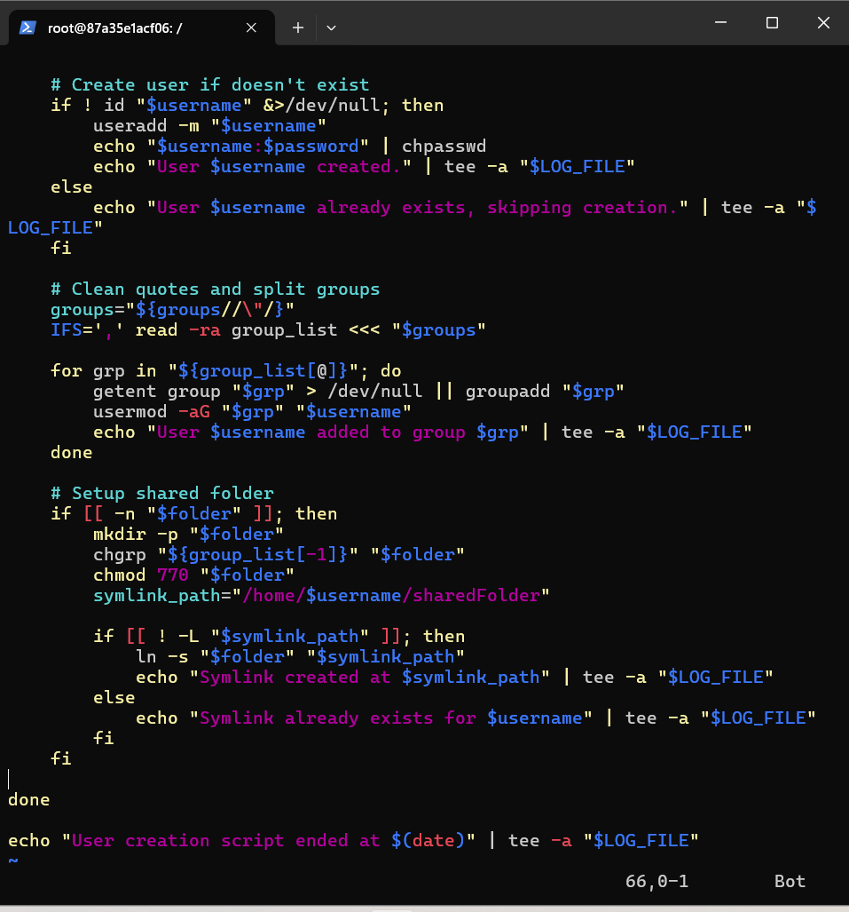

Got errors of not making users because they already exists

I have tried with old csv and runned the mymanagers .sh 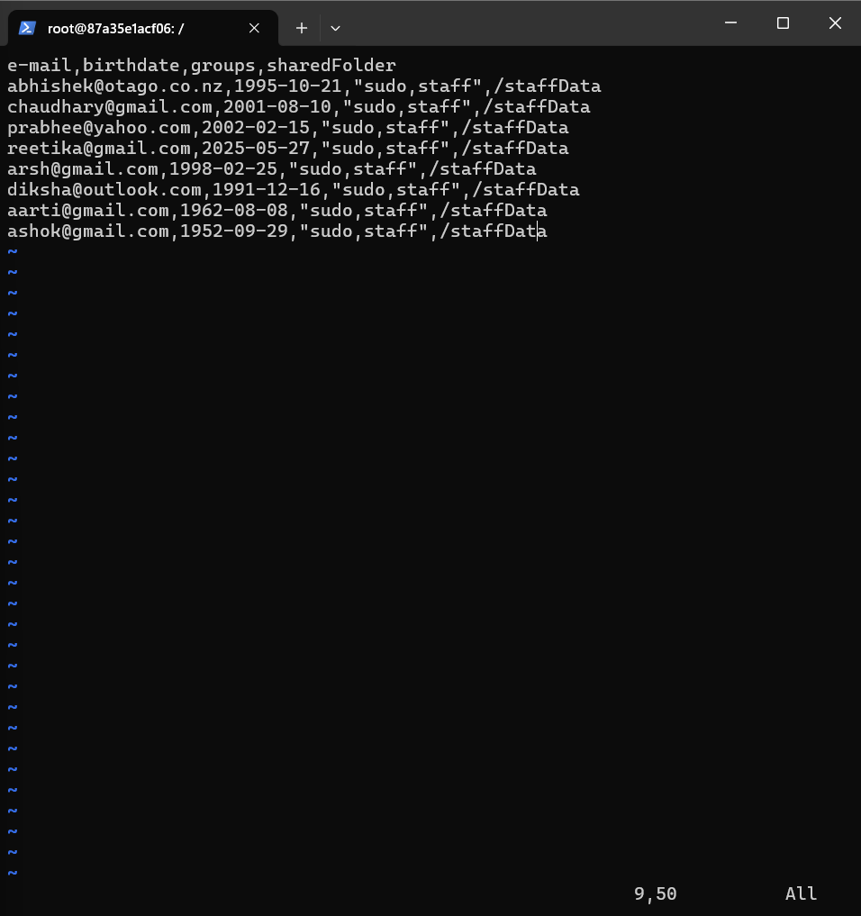

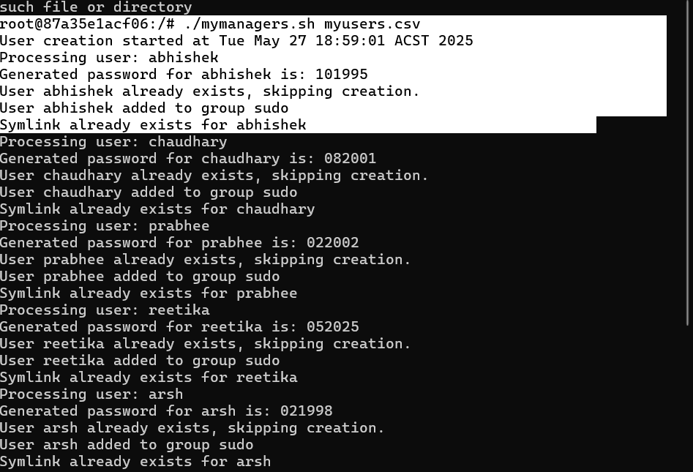

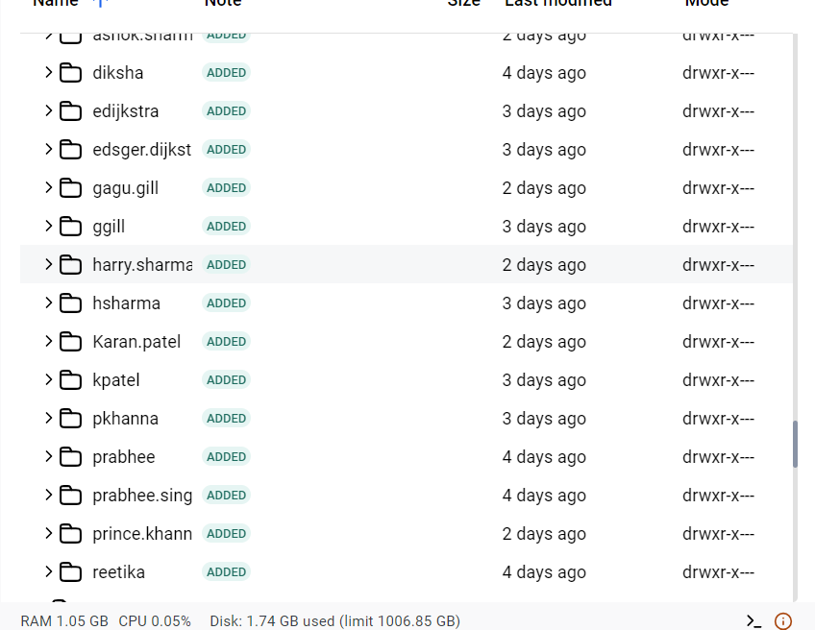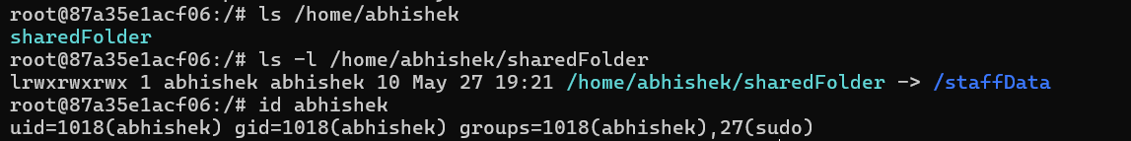

Cat /etc/passwd “:

List of all users

